SIMATS ENGINEERING
ASSESSMENT TOOL 2
Case study

STUDENT NAME: DIVYA SHREE.K
Reg.No:192521376
COURSE NAME: Computer Networks COURSE CODE: CSA0706

COURSE OUTCOME COVERED

CO3: Analyze the performance of core network protocols such as TCP, UDP, HTTP, and DNS under varying conditions

Assessment Tool Weightage: 40%

Case study

QUESTIONS:4 Total Marks:40

1.A multinational IT company uses a cloud-based video conferencing platform for daily client meetings. During peak business hours, employees experience frequent voice distortion, frozen video frames, and delayed communication. Network monitoring reports indicate an 8% packet loss, 180 ms jitter, and fluctuating bandwidth utilization. The IT administrator suspects that the issue is related to the transport protocol or application-level buffering strategy.

Questions
- Analyze whether the problem is primarily caused by the transport protocol (TCP/UDP) or the application layer.
- Justify your answer based on the communication requirements of real-time multimedia applications.
- Recommend suitable protocol-level or application-level improvements to enhance conferencing quality.
2.A multinational software company hosts its web services across multiple continents. Employees frequently report long delays before the application homepage loads. Network analysis shows that the average DNS lookup time is approximately 800 ms, significantly affecting user experience. The organization plans to redesign its DNS infrastructure while ensuring continuous service availability during server failures.

Questions
- Analyze the reasons behind the high DNS resolution time.
- Propose a suitable DNS architecture using techniques such as Anycast DNS, DNS pre-fetching, and TTL optimization to reduce the lookup time below 50 ms.
- Evaluate the advantages and limitations of your proposed architecture in terms of performance, scalability, and availability.
3.A cloud service provider delivers applications to millions of users worldwide. During promotional events, users experience intermittent delays in accessing cloud-hosted services. Investigation reveals that DNS queries are taking nearly 800 ms because all requests are directed to a single primary DNS server. The company wants a highly available DNS solution capable of handling global traffic efficiently.

Questions
- Examine the impact of centralized DNS architecture on application performance.
- Design a distributed DNS solution that minimizes lookup latency while maintaining high availability.
- Analyze how TTL values, Anycast routing, and DNS caching influence system performance and fault tolerance.
4.A financial institution operates an electronic stock trading platform where thousands of buy and sell orders are submitted every second. During market opening hours, the average order acknowledgment latency increases from 1 ms to 40 ms, resulting in delayed trade confirmations and customer dissatisfaction. Network engineers observe increased TCP retransmissions, longer connection establishment times, and excessive buffering.

Questions
- Analyze three possible TCP-related factors responsible for the latency increase, considering flow control, Nagle's algorithm, and SYN queue limitations.
- Explain how each factor affects transaction processing in high-frequency systems
- Recommend appropriate TCP configuration changes to reduce latency and improve transaction reliability.
RUBRICS FOR CALCULATION

Criteria | Weightage | Level 4 – Exemplary | Level 3 – Proficient | Level 2 – Developing | Level 1 – Beginning
Understanding of Case | 25 | Thorough understanding; clearly identifies all key issues | Good understanding with most issues identified | Basic understanding; some issues missed | Poor understanding; problem not identified correctly
Application of Concepts | 25 | Effectively applies relevant concepts to analyze the case deeply | Applies appropriate concepts with minor gaps | Limited application of concepts | Fails to apply relevant concepts
Analysis | 20 | In-depth analysis with strong reasoning and insights | Good analysis with logical reasoning | Basic analysis with limited depth | Weak or no analysis; lacks reasoning
Solution Design | 20 | Innovative, feasible solutions with strong justification | Logical solutions with adequate justification | Basic solutions with weak justification | Incorrect or no solution provided
Clarity | 10 | Clear, well-structured, and easy to understand | Organized and understandable presentation | Limited clarity and structure | Poor clarity; difficult to understand

1. Cloud-Based Video Conferencing Performance Issues

Answer 1: Analyze whether the problem is caused by the transport protocol or the application layer.
The problem is mainly related to the transport protocol (UDP) and application-layer buffering. Video conferencing applications usually use UDP because it provides faster transmission without waiting for lost packets to be retransmitted. However, the reported 8% packet loss and 180 ms jitter indicate unstable network conditions. High jitter forces the application to increase its playback buffer, causing delays and frozen video.
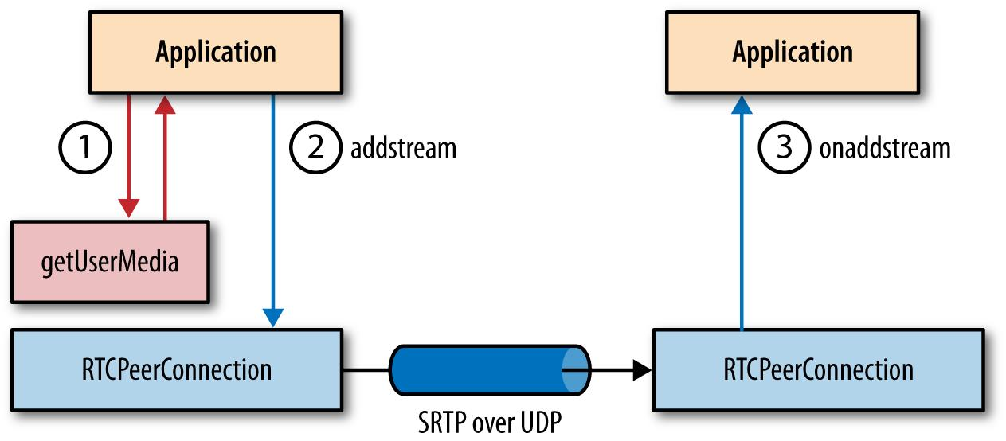

Answer 2: Justify your answer.
Real-time multimedia applications require:
- Low latency
- Low jitter
- Continuous audio and video delivery
UDP is preferred because it avoids retransmission delays. TCP is not suitable because retransmissions and acknowledgments increase latency, making voice and video lag.
The application uses a jitter buffer to smooth packet arrival. When jitter becomes too high, the buffer increases, resulting in delayed communication.

Answer 3: Recommendations
Protocol-Level Improvements
- Continue using UDP with RTP/RTCP.
- Implement Quality of Service (QoS) to prioritize voice and video traffic.
- Reduce packet loss through network optimization.
Application-Level Improvements
- Use adaptive bitrate streaming.
- Optimize jitter buffer size.
- Enable Forward Error Correction (FEC).
- Compress audio and video efficiently.

2. DNS Resolution Delay in a Multinational Software Company

Answer 1: Reasons for High DNS Resolution Time
High DNS lookup time (800 ms) may be caused by:
- Centralized DNS server located far from users.
- High DNS server workload.
- Long network routing paths.
- No DNS caching.
- Incorrect TTL configuration.
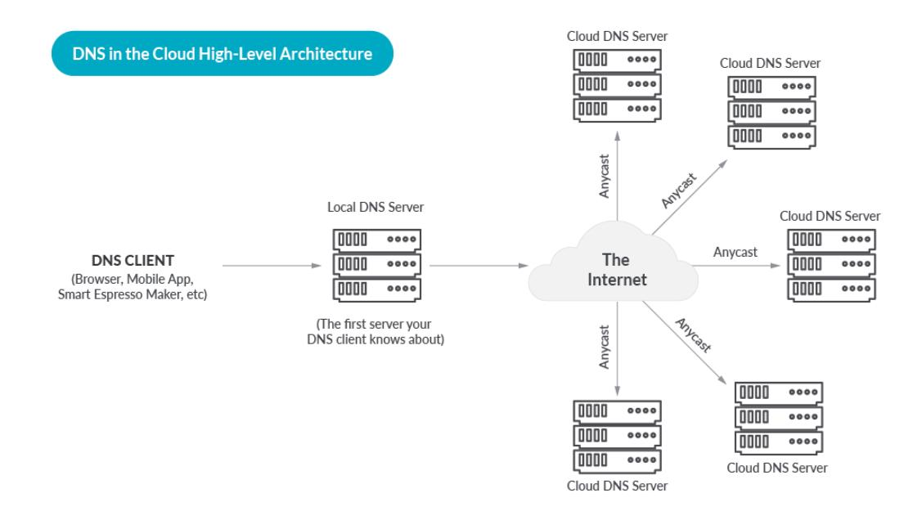

Answer 2: Proposed DNS Architecture
The organization should implement:
- Anycast DNS to route users to the nearest DNS server.
- DNS Caching to store recently resolved domain names.
- DNS Pre-fetching to resolve frequently accessed domains in advance.
- TTL Optimization (300–600 seconds) to balance performance and updates.
These techniques can reduce DNS lookup time to below 50 ms.

Answer 3: Advantages and Limitations
Advantages | Limitations
Faster DNS resolution | Higher deployment cost
High availability | More complex management
Better scalability | Cache synchronization required
Reduced server load | TTL tuning needed

3. Distributed DNS Solution for a Cloud Service Provider

Answer 1: Impact of Centralized DNS
A centralized DNS server:
- Creates a single point of failure.
- Increases lookup latency for distant users.
- Causes server overload during high traffic.
- Reduces application performance.
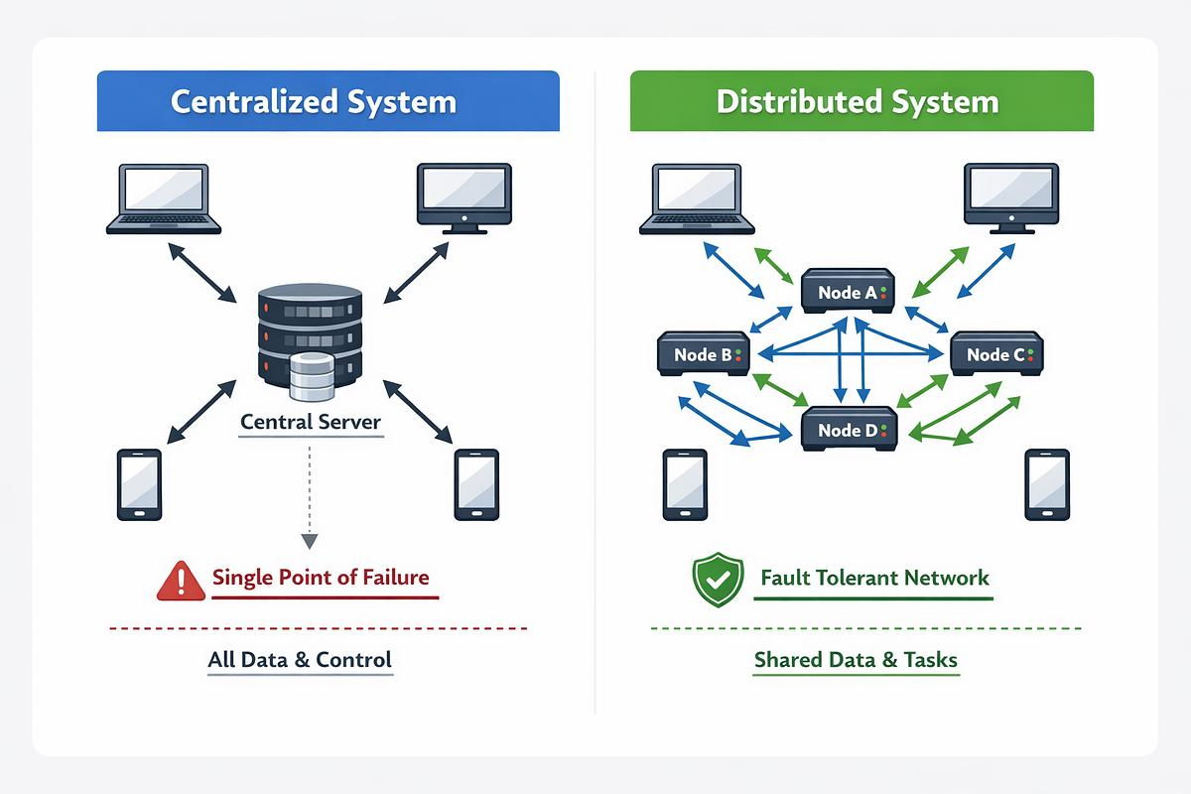

Answer 2: Distributed DNS Solution
A distributed DNS architecture should include:
- Multiple DNS servers in different geographic regions.
- Anycast routing to direct users to the nearest server.
- DNS caching at local resolvers.
- Secondary DNS servers for failover.
This design reduces lookup delays and improves availability.

Answer 3: Role of TTL, Anycast, and DNS Caching
TTL (Time-To-Live)
- Controls how long DNS records remain in cache.
- Lower TTL allows faster updates.
- Higher TTL reduces DNS queries.
Anycast Routing
- Directs users to the nearest DNS server.
- Reduces latency.
- Improves fault tolerance.
DNS Caching
- Stores previously resolved addresses.
- Reduces repeated DNS lookups.
- Improves response time.

4. TCP Latency in an Electronic Stock Trading Platform

Answer 1: Three TCP-Related Factors

1. Flow Control
When the receiver cannot process data quickly, TCP reduces the sending rate. This slows order processing and increases latency.

2. Nagle's Algorithm
Nagle's algorithm combines small packets before sending them. Although it reduces network overhead, it introduces delays that are unsuitable for real-time stock trading.

3. SYN Queue Limitations
If many connection requests arrive simultaneously, the SYN queue becomes full. New connection requests are delayed or dropped, increasing connection establishment time.
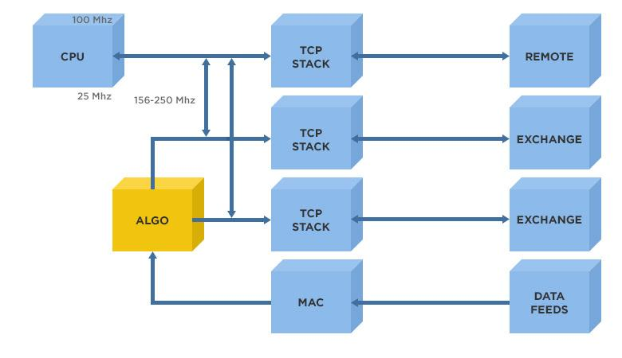

Answer 2: Effect on Transaction Processing
Factor | Effect
Flow Control | Slower order acknowledgments
Nagle's Algorithm | Delayed transmission of small trade orders
SYN Queue Limitations | Increased connection setup delays and possible request drops

Answer 3: Recommended TCP Configuration
- Disable Nagle's Algorithm using TCP_NODELAY.
- Increase the TCP SYN queue size.
- Enable TCP Fast Open to reduce connection setup time.
- Tune TCP buffer sizes for better flow control.
- Use persistent connections to avoid repeated handshakes.
- Enable Selective Acknowledgment (SACK) to improve retransmission efficiency.

Overall Conclusion
The case studies demonstrate the importance of optimizing transport protocols, DNS infrastructure, and TCP configurations to improve network performance. Using UDP with QoS for multimedia applications, distributed DNS with Anycast and caching for faster name resolution, and optimized TCP settings for low-latency financial systems significantly enhances reliability, scalability, and user experience.

